William Stafford, Ask Me: 100 Essential Poems, Greywolf Press First Ed First Print, 2014, Designer Rachel Holscher. No DJ. As new softcover all 109 pages tight and unmarked in any way. "Offers a collection of poetry culled from the fifty books the poet published in his lifetime." [from publisher] Includes a facsimile page of the first draft of ‘Ask Me.’”
William Stafford former Oregon poet laureate.
“I know no other twentieth-century American writer as much admired and respected aas Willima Stafford.” Ted Kooser former US poet laureate. ISBN 9781555976644

ID 000126 Price $8.00
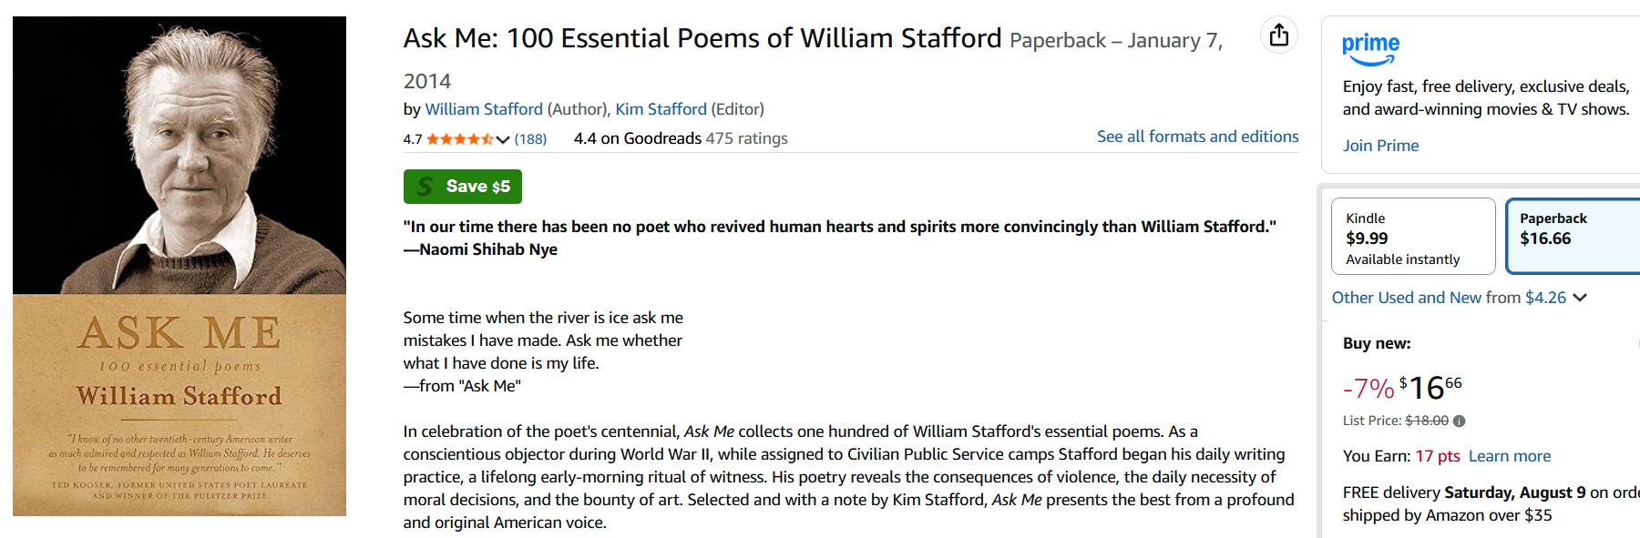
Amazon $17
AbeBooks $2.78 to $22

